**Special Declaration**

All the content of this manual have been already checked carefully, Any misunderstanding or printing error will be kept by the manufacturer.

Any technical improvement will recorded into the new manual which printed newly ,Any chance of color and design will nor noticed by manufacturer ,Please check the real products.

**Please read this operation manual carefully before using the induction cooker in the right way**

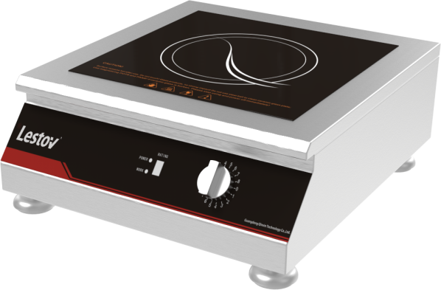

**Induction single flat Cooker Operation Manual**

**LT-TPM-B13 (3 KW-230V)**

* Thanks for choosing our Induction Cooker.
* Please read this manual before using.
* Please keep this manual after reading for checking in the future.
* The company reserves the right to modify

**INTRODUCTION**

**1.Operating principle**

The Induction cooker is a kind of new kitchen products in kitchenware market, which had broken the traditional way of cooking by using the most advanced magnetic field induction eddy current heating technology. As current cross the coil and the magnetic field will be formed. When this magnetic line cross through the magnetic field and whirlpool have been formed and make effect of pot or boiler, heating up the food in the pot.

**2.Mark Meaning**

GB/T 5465.2-5140 None [ionization](app:ds:ionization) [electromagnetic](app:ds:electromagnetic) [radiation](app:ds:radiation) Indicating the radiation is higher than normal standard or there is potential risk; or indicating the device or the system for example the radiate equipment in diagnosis or treatment or the areas of applying medical electronics device which used radio frequency electromagnetic energy firing.



GB/T 5465.2-5036 [Dangerous](app:ds:dangerous) [voltage](app:ds:voltage) Meaning dangerous voltage, caused danger.



Earthed circuit Identifying the terminal of outside protection conductor which prevents electric shock or the terminal connected with the protective earth electrode.

**3.Technical Specification**

1. Magnetic field induction eddy current heating technology

Current(17-40)kHz cross the coil and make magnetic field, when magnetic line cross the field ,heat will be caused to heat the pot and cook the food in the pot.

2. A C：230V Currency：50Hz Power: 3 KW

3. The requirement for the pot which used in the cooker

Because the no-magnetic materials have not make the magnetic line , So the whirlpool cannot be formed ,and so ,the heat cannot be made. Moreover the magnetic materials with bad electric conduction cannot make bigger whirlpool which need to make little heat(P=I²R). So only high conductive material can used as the induction pot, such as iron pot, A3 iron pot, stainless steel pot. etc.

NOTE：Without any operation for more than 3 hours, the cooker will shut off automatically.

69

**8. Error and Maintenance**

When the cooker do not work, please check：

|  |  |
| --- | --- |
| Error | Maintenance |
| 1. Power on, No “Bee” | |
| ①Check the main power cable; | ok |
| ②Check power switch power or leakage; | Check leakage and circuit |
| 2. No working after switch on and no heating; | |
| ①power switch is not in shut off gears when powered on | Switch the knob to shut off, restart |
| ②Switch on ,LED no changing | Knob switch is broken, change a new knob |
| 3. When cooker working, no response or power reduce down and return to normal and repeat this error; | No operating cooker for more than 2 hours, Restart the cooker.  Overheat protection, Check the power connection and fan working or not. |
| 4. When heating, LED display shows "3" or "8"; | Switch reset, restart |

|  |  |  |  |  |  |
| --- | --- | --- | --- | --- | --- |
| **9.Error Code** | | | | | |
| E1/1 | No pot | E5/5 | IGBT Thermistor cut off | E9/9 | Short circuit |
| E2/2 | Overheat for bottom pot | E6/6 | Low Voltage | EA/A | Wire coil cut off |
| E3/3 | Thermistor cut off | E7/7 | High Voltage | EB/B | Fan no working |
| E4/4 | IGBT Overheat | E8/8 | IGBT Over current |  |  |
|  |  |  |  |  |  |

**6. Installation and Debugging**

1. The water input part is at the back top part of the induction cooker. And the wire part is at bottom of the induction stove, with voltage 230V 1phase，should install with suitable current leakage protection switch, Please consult professional for this.

2. Keep the cooker’s back panel 35 CM away from the wall for maintenance. If cannot leave such distance, at least leave 5CM for heat radiation

**7.Introduction of Operation**

1. Make the power switch to the “0” position
2. After switching on, with “Bee” and all the LED display will flash one time. one second later, power light (red) flickers, and then the working lights(blue) shut down.
3. Twist the magnetic switch, the power light and the working light flash, the cooling fan works, the display shows "1", the stove starts work at gear "1"; then adjust the switch to different power and the LED shows the working gears. When twist the gears the stove sounds “Bee” and there are 8 gears.
4. After cook finished, twist the switch to “0”, LED will display “0”, power light and working light will be shut off , Motor fan will continue working for 1 Minute and then power off automatically.
5. After the fan stop working, shut off the power.

7

1. After using, the way of controlling the close unit cannot be depend on the temperature detector in the cooker.

7. This equipment is suitable for ambient temperature: - 10 ~ 38 ℃, humidity ≤90%.

4. The Structural Representation

(Front View)

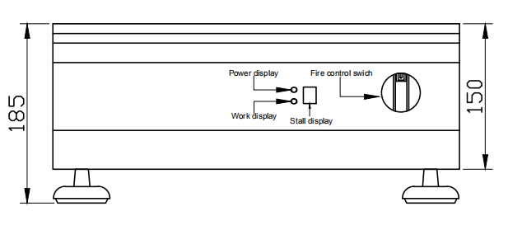

(Side Vie(Side View)

(Side View)

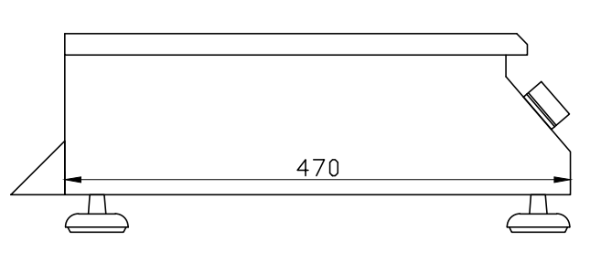

(Upward View)

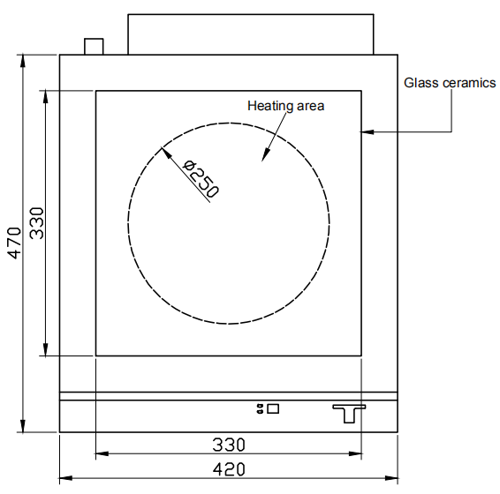

(Top view)

1. **Safety and maintenance**

1.Please read the manual carefully before using the cooker.

2. The core part of the cooker should be dry and ventilated, the table-top induction cooker should be used at the dry and clean table . Prohibit to splash on the back wall of the cooker, avoid splash back to the air outlet & damage the cooker. ( Waterproof Grade of the cooker is IPX4) .

3 We must make sure the kitchen are good ventilation, if not good, there will be so much waste fume, which can lead high frequency failure and short working life of the products.

4 Don’t cover the LED Display when cooker work.

5 Cannot place the metal in cooking area, such as fork, spoon., etc, for it will be heated.

6 .Please don’t wear ring & watch during cooking.

7. Please prohibit the children from using the induction cooker.

8. If user should work with Cardiac pacemakers, please contact the supplier first.

9. Don’t worry put any aluminum foil or plastic pot on high temperature surface, and this surface cannot hold things.

10. The products cannot be washed by water shooting, and no flushing water from products, bottom and do not block air inlet.

11 When using the cooker, please don’t switch the knob frequently, which may lead no operation effect or broken it. And if so, the broken part is not in warranty.

1. Don’t off the “Power” when the cook on work, which may broken the power switch.
2. Make sure the cooker stop work & motor fan stop work, then cut off the electricity.

14.When connecting the product with power, should contact with a 3mm GFCI first.

15. If abnormal thing appear on the machine, don’t repair privately, should consult the professional people.

16. Before cleaning the product, make sure disconnected power, and when using it again, make sure the connecting joint dry.

17. The products must be used with its marched pot.

18. Warning: If the power cable damaged, should replace by professional people.

19. Warning: It’s in high voltage inside of the cooker, prohibit to dismantle the machine privately.

20.Warning: This manual not apply to physical or mental defect people (include children)

21. Warning: If the cooker cracking, turn off the electricity rapidly.

22. Warning: If the cooker glass break, turn off the electricity rapidly to avoid electric shock .

23. Warning: before touch cable terminal, cut off the power.

24. Warning: before the pressure reduce to normal atmospheric pressure, do not open the switch or air out switch.

25. Warning: when install the cooker do not place it near the wall, panel or other machine, suggest cover that with non-combustible materials, and careful for fire regulations.

1. **Cleaning and Maintain**
   * + When cleaning the induction cooker, it must be powered off, strictly prohibit flushing water or clean with the steam cleaner, should be cleaned with cleaning cloth.
     + To ensure the good heat dissipation efficiency of the core machine, we suggest its inlet should be cleaned monthly.